

**PROJECT TITTLE:**

INSIGHTSTREAM NEWS NAVIGATION

**PROJECT ID:** NM2025TMID39313

**TEAM LEADER:**

# **NAME:** VIGNESH. V

**MAIL ID: VINESH @gmail.com**

**TEAM MEMBERS:**

# **NAME:** KATHIRESAN. A

# **MAIL ID:** kathiresan3108a@gmail.com

# **NAME:** SURENDHAR **. R MAIL ID:** [**sura54312@gmail.com**](mailto:sura54312@gmail.com)

# **NAME**:RICKY. E

# **MAIL ID:** rickychoco7010@gmail.com

**1.PURPOSE:**

* To Give Easy, Clear, and Quick Access.
* Save Time An Give a Smooth Learning Journey.

**2.PROJECT OBJECTIVE:**

* User-Friendly Interface: ▪ Students Quickly Find Cources, Resources, And Career Opportunities.
* Improve Their Overall Learning Experience.

**3.ARCHITECTURE:**

o FRONTEND:

* React.js and vita o BACKEND**:**
* Node.js and Express.js

**4.SETUP INSTRUCTIONS:** o PRE-REQUISITES:

* Node.js and npm
* React.js
* Node.js
* MongoDB
* Git
* Visual studio Code

o INSTALLATION STEPS:

* Install React.js
* Create a new React app:
* Navigate to project Directory ▪ Running the React App
* Start the development server ▪ Install Dependencies
* Start the Development Server
* Access the App
* Navigate to http://localhost:3000.

**5.PROJECT STRUCTURE**

> Node modulus

>Public

> s r c

> assests

>Components

App.css

App.jsx

Index.css

Main.jsx

.eslintrc.cjs

.gitignore

Index.html

Package-lock.json

Package.json

README.md

Vite.config.js

**6.RUNNING THE APPLICATION:**

* FRONTEND:
  + cd client npm start o BACKEND:
  + cd server npm start

**7.AUTHENTICATION**

* + JWT- Based authentication for secure login
  + Middleware protects private routes

**8.API DOCUMENTATION** o USER:

* + -/api/user/register
  + -/api/user/login

* PROJECTS:

▪ -/api/projects/create ▪ -/api/projects/:id

o APPLICATIONS:

* -/api/apply

**9.USER INTERFACE:**

* Landing Page
* Freelancer Dashboard
* Admin Panel
* Project Details Page

**10.TESTING:**

* Manual testing ▪ TOOLS:
* Chrome Dev Tools
* Browser Dev Tools

1. **SCREENSHOTS :**

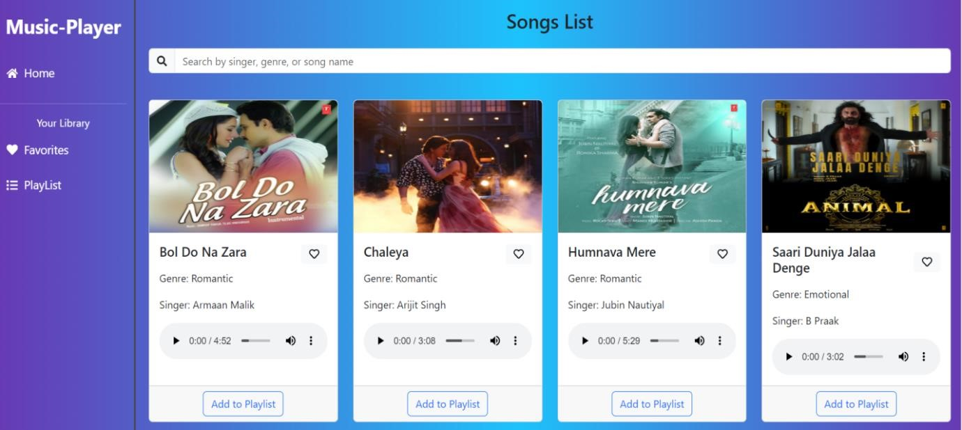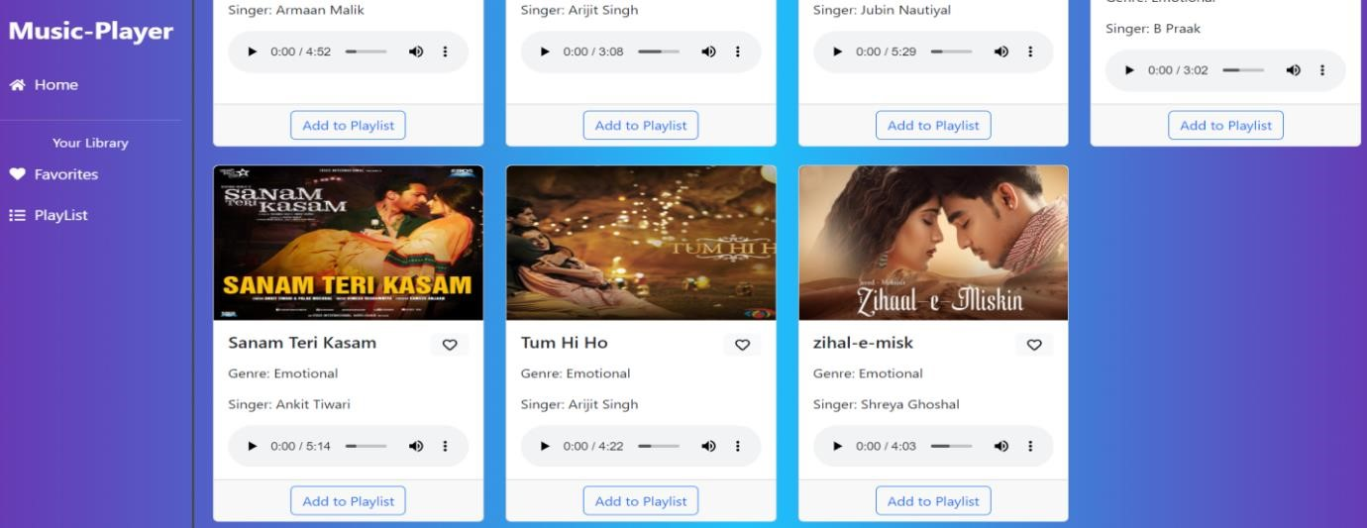

* + PLAYLIST

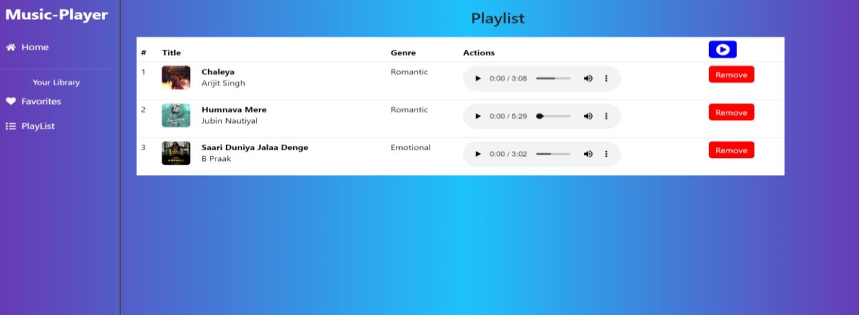

* + FAVOURITES:

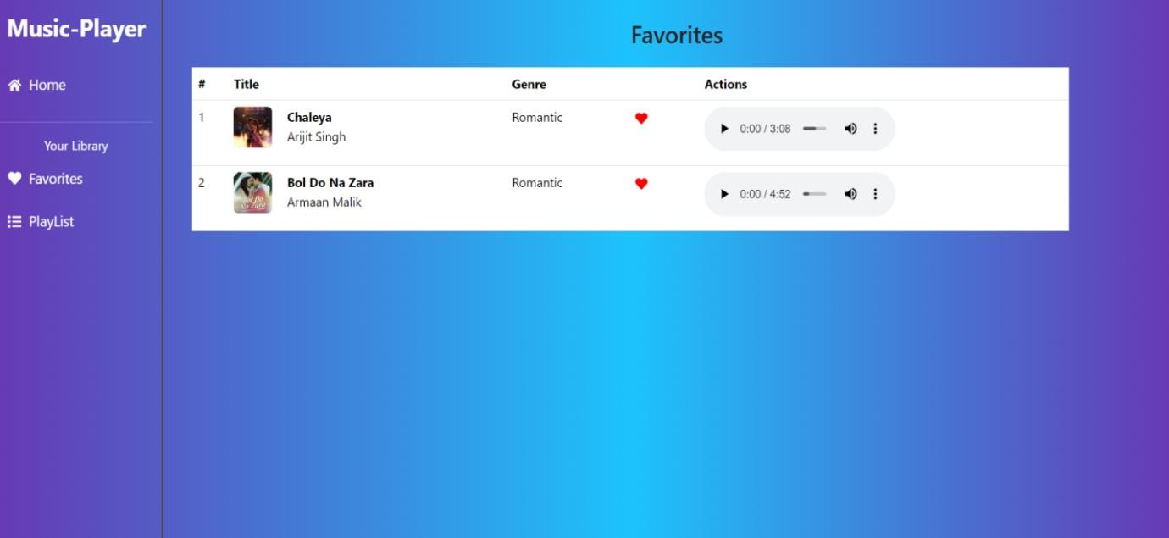

1. **KNOWN ISSUES:** 
   * CORS (Cross Origin Resource Sharing)
   * Incorrect Data Formatting

**13.FUTURE ENHANCEMENT:**

* + Advanced Audio
  + Visualizers Features
  + External API Integration